1) Create react app
then in index.js
register service worker
serviceWorker.register();

when we look at serviceWorker.js file ,
export function register(config) {
if (process.env.NODE_ENV === 'production' && 'serviceWorker' in

We see that serviceWorkers only registers in production mode

If we dont do that , it cause cacheing problems in development mode

now to see result, first build app and then serve build version

if we see console, we see msg like

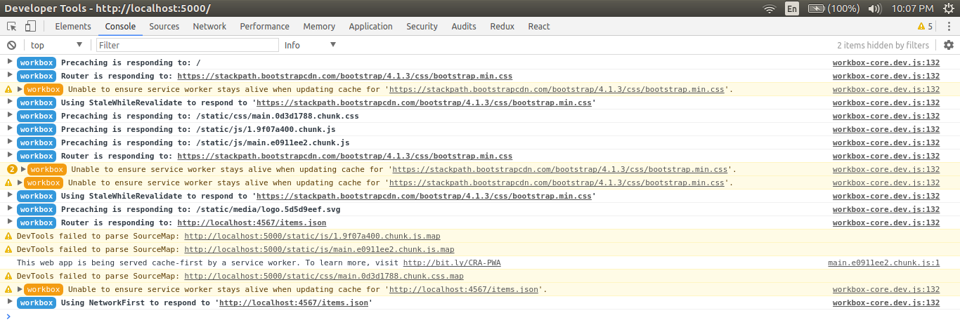

and if we see network tab , we see that almost all resources are comming from service workers (see in size tab of network)

Now if we close our build and then try to refresh page, it will still load

Note that only static assets will load if no internet

2 – Debug anbd development setting
in application tab of chrome tool there is optn of service workers
we can see name and date of service worker
here tick the checkbox “update on reload” which will update service workers with latest one in development mode

In prodection mode , to refresh service worker , just close all tabs containing our page and load again

tick on offline checkbox to make tab in offline mode

If we check “bypass for network” , it willl load all resources from webserver and not serviceworker

now unselect all checkbox and now lets simulate real user
load website
now change h1 tag or any such tag...then close react server, build and serve again
now reload page....it will still show previous vrsion
if we close tab and load page again , it will show new version

3 – Creating new service worker without ejecting

create a new file called my-service-worker.js in public directory (name can be anything)
add
console.log("Hello from custom service worker");

and the open serviceWorker.js
replace existing name of service worker with new name
window.addEventListener('load', () => {
const swUrl = `${process.env.PUBLIC_URL}/my-service-worker.js`;

now build , serve and run app
in console we can see our log msg
also in application tab, we can see new service worker name

now delete custom service worker and also revert change in serviceWorker.js we made of name
now build again and serve

4 – Now
npm i -D react-app-rewired
which is used to rewrite webpack config without ejecting

make a newfile called config-overrides.js in root of the project

module.exports = function override(config, env) {
console.log("config: ", config);

// return config;
};

here we are logging to see config object, it will break , but we will able to see config obj

now replace package.json scripts
"scripts": {
"start": "react-app-rewired start",
"build": "react-app-rewired build",
"test": "react-app-rewired test",
"eject": "react-app-rewired eject"
},

now build app

we can see error but we can see config object
here we want to replace
GenerateSW { config: [Object] } ],
with better plugin

in config-override.js
const WorkboxWebpackPlugin = require("workbox-webpack-plugin");

module.exports = function override(config, env) {
config.plugins = config.plugins.map(plugin => {
if (plugin.constructor.name === "GenerateSW") {
return new WorkboxWebpackPlugin.InjectManifest({
swSrc: "./src/sw.js",
swDest: "service-worker.js"
});
}
return plugin;
});

return config;
};

create a new file in src called sw.js
console.log("Custom new serviceworker");

workbox.skipWaiting();
workbox.clientsClaim();

here we are telling workbox install serviceworkers on client rightaway

build again and serve and close and open tab and in console we can see msg

